**Web Designing Assignment**

**Term-1**

**Module (HTML) -1**

**1)Are the HTML tags and elements the same thing?**

HTML tags and elements are not the same thing.

A HTML tag is like a container for either content or other HTML tags.

A HTML element consists of the **start tag + content tag + end tag**. Some HTML tags do not have end tags like <img> hence in those cases HTML element will consist of start tag + content.

**2) What are tags and attributes in HTML?**

HTML tags are what defines where an HTML element starts and where it ends. There is usually an opening bracket followed by the element’s name and, finally, a closing bracket.

In simple words, an HTML attribute is what modifies an HTML element. It is usually in the form of unique words that one inserts inside the opening tag. They control the behavior of the element that follows.

**3) What are void elements in HTML?**

Most of the HTML elements are surrounded by start and end tags to specify the starting and end of the element.

There is a special group of elements that only have start tags and does not contain any content within it, these elements are called void elements. Void elements

doesn’t have ending tags and can only have attributes but do not contain any kind of content. These elements can have backslash before ending of start tag but

that is completely optional.

Example of such elements are <br>, <hr>, <img>, <input>, <link>, <base>, <meta>, <param>, <area>, <embed>, <col>,

<track>, <source> etc.

**4) what are html entities?**

HTML character entities are used as a replacement of reserved characters in HTML. You can also replace characters that are not present on your keyboard by entities.

These characters are replaced because some characters are reserved in HTML. HTML entities provide a wide range of characters which can allow you to add icons, geometric shapes, mathematical operators, etc.

You can use an entity in your HTML document by name or by a numerical character reference. Each entity starts with symbol ampersand (&) and ends with a semicolon (;).

**Syntax:**

**1. Using a Character Entity**

& [Entity name character];

**2. Using Number**

&#Entity no;

**5) What are different types of lists in HTML?**

HTML Lists help to display a list of information semantically. There are three types of lists in HTML:

* Unordered list or Bulleted list (ul)
* Ordered list or Numbered list (ol)
* Description list or Definition list (dl)
* **HTML Unordered List or Bulleted List**

In HTML unordered list, the list items have no specific order or sequence. An unordered list is also called a Bulleted list, as the items are marked with bullets. It begins with the <ul> tag and and closes with a </ul> tag. The list items begin with the <li> tag and end with </li> tag.

**Syntax:**

<**ul**>List of Items</**ul**>

Example of HTML Unordered List

<!DOCTYPE html>

<**html**>

<**head**>

<**title**>HTML Unordered List</**title**>

</**head**>

<**body**>

<**h2**>List of Fruits</**h2**>

<**ul**>

<**li**>Apple</**li**>

<**li**>Mango</**li**>

<**li**>Banana</**li**>

<**li**>Grapes</**li**>

<**li**>Orange</**li**>

</**ul**>

</**body**>

</**html**>

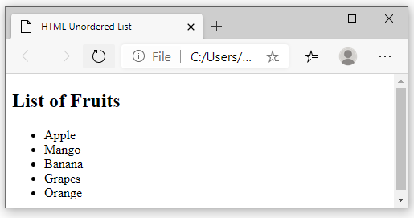

## Ordered List or Numbered List (ol)

In [HTML](https://www.naukri.com/learning/what-is-html-st619-tg25), all the list items in an ordered list are marked with numbers by default instead of bullets. An HTML ordered list starts with the <ol> tag and ends with the </ol> tag. The list items start with the <li> tag and end with </li> tag.

**Syntax:**

<**ol**>List of Items</**ol**>

#### Example of HTML Ordered List

<!DOCTYPE html>

<**html**>

<**head**>

<**title**>HTML Ordered List</**title**>

</**head**>

<**body**>

<**h2**>List of Fruits</**h2**>

<**ol**>

<**li**>Apple</**li**>

<**li**>Mango</**li**>

<**li**>Banana</**li**>

<**li**>Grapes</**li**>

<**li**>Orange</**li**>

</**ol**>

</**body**>

</**html**>

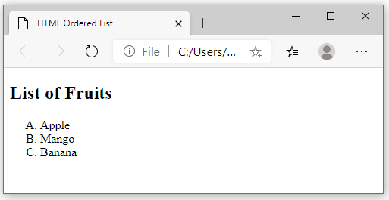

### Different Types of Ordered Lists in HTML

Instead of numbers, you can mark your list items with the alphabet: A, B, C or a,b,c, or roman numerals: i, ii, iii, etc. You can do this by using the type attribute in the <ol> tag. Let’s explore how to order lists with alphabets and roman numbers.

To mark the list items with letters A, B, C, etc., you will have to specify A as the type attribute’s value in the <ol> tag.

**Here is an example to show the use of Upper case letters to list the items.**

<!DOCTYPE html>

<**html**>

<**head**>

<**title**>HTML Ordered List</**title**>

</**head**>

<**body**>

<**h2**>List of Fruits</**h2**>

<**ol** type="A">

<**li**>Apple</**li**>

<**li**>Mango</**li**>

<**li**>Banana</**li**>

</**ol**>

</**body**>

</**html**>

**Output:**



**Here is an example to show the use of Lower case letters to list the items.**

<!DOCTYPE html>

<**html**>

<**head**>

<**title**>HTML Ordered List</**title**>

</**head**>

<**body**>

<**h2**>List of Fruits</**h2**>

<**ol** type="a">

<**li**>Apple</**li**>

<**li**>Mango</**li**>

<**li**>Banana</**li**>

</**ol**>

</**body**>

</**html**>

**Output:**

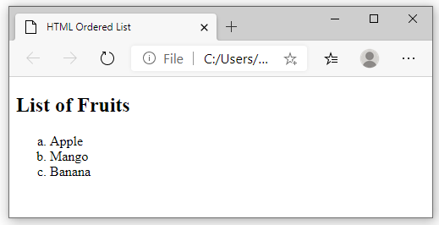

**Here is an example to show the use of Roman numerals to list the items.**

<!DOCTYPE html>

<**html**>

<**head**>

<**title**>HTML Ordered List</**title**>

</**head**>

<**body**>

<**h2**>List of Fruits</**h2**>

<**ol** type="i">

<**li**>Apple</**li**>

<**li**>Mango</**li**>

<**li**>Banana</**li**>

</**ol**>

</**body**>

</**html**>

**Output:**

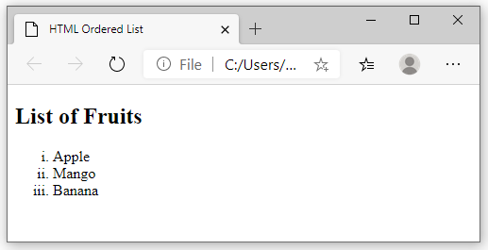

## HTML Description List or Definition List

In an HTML Description list or Definition List, the list items are listed like a dictionary or encyclopedia. Each item in the description list has a description. You can use a description list to display items like a glossary. You will need the following [HTML tags](https://www.naukri.com/learning/articles/html-tags/) to create a description list:

* <dl> (Definition list) tag – Start tag of the definition list
* <dt> (Definition Term) tag – It specifies a term (name)
* <dd> tag (Definition Description) – Specifies the term definition
* </dl> tag (Definition list) – Closing tag of the definition list

#### HTML Description Example List

<!DOCTYPE html>

<**html**>

<**head**>

<**title**>HTML Description List</**title**>

</**head**>

<**body**>

<**dl**>

<**dt**><**b**>Apple</**b**></**dt**>

<**dd**>A red colored fruit</**dd**>

<**dt**><**b**>Honda</**b**></**dt**>

<**dd**>A brand of a car</**dd**>

<**dt**><**b**>Spinach</**b**></**dt**>

<**dd**>A green leafy vegetable</**dd**>

</**dl**>

</**body**>

</**html**>

**Output:**

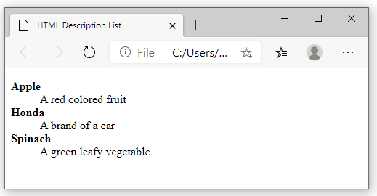

* **HTML Nested Lists**

An HTML Nested list refers to a list within another list. We can create a nested ordered list, a nested unordered list, or a nested ordered list inside an unordered list.

Let us explore some examples of HTML lists within lists:

Example of an HTML Nested Ordered List

<!DOCTYPE html>

<**html**>

<**head**>

<**title**>HTML Nested Ordered List</**title**>

</**head**>

<**body**>

<**ol**>

<**li**>Banana</**li**>

<**li**> Apple

<**ol**>

<**li**>Green Apple</**li**>

<**li**>Red Apple</**li**>

</**ol**>

</**li**>

<**li**>Pineapple</**li**>

<**li**>Orange</**li**>

</**ol**>

</**body**>

</**html**>

**Output:**

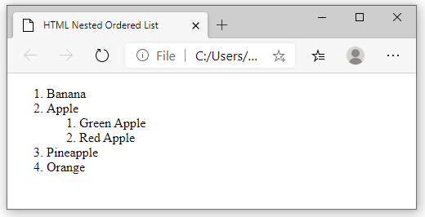

* **Example of an HTML Nested Unordered List**

<!DOCTYPE html>

<**html**>

<**head**>

<**title**>HTML Nested Unordered List</**title**>

</**head**>

<**body**>

<**ul**>

<**li**>Fruits</**li**>

<**ul**>

<**li**>Apple</**li**>

<**li**>Banana</**li**>

<**li**>Mango</**li**>

<**li**>Orange</**li**>

</**ul**>

<**li**>Vegetables</**li**>

<**ul**>

<**li**>Spinach</**li**>

<**li**>Cauliflower</**li**>

<**li**>Beetroot</**li**>

</**ul**>

<**li**>Cereals</**li**>

<**li**>Nuts</**li**>

</**ul**>

</**body**>

</**html**>

**Output:**

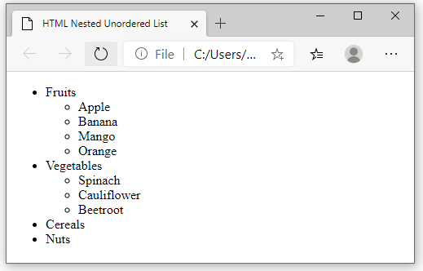

**6) What is the ‘class’ attribute in HTML?**

**Class in html:**

* The class is an attribute which specifies one or more class names for an HTML element.
* The class attribute can be used on any HTML element.
* The class name can be used by CSS and JavaScript to perform certain tasks for elements with the specified class name.

**Example :**

|  |
| --- |
| <!DOCTYPE html>  <html>  <head>      <style>          .country {              background-color: black;              color: white;              padding: 8px;          }      </style>  </head>  <body>      <h2 class="country">CHINA</h2>    <p>China has the largest population         in the world.</p>        <h2 class="country">INDIA</h2>    <p>India has the second largest         population in the world.</p>        <h2 class="country">UNITED STATES</h2>    <p>United States has the third largest         population in the world.</p>    </body>  </html> |

**7) What is the difference between the ‘id’ attribute and the ‘class’ attribute of HTML elements?**

The only difference between them is that **“id” is unique in a page and can only apply to at most one element, while “class” selector can apply to multiple elements**.

**HTML id Attribute:** The id attribute is a unique identifier which is used to specify the document. It is used by CSS and JavaScript to perform a certain task for a unique element. In CSS, the id attribute is written using # symbol followed by id.  
**Syntax:** 

<element id="id_name">

In CSS Stylesheet:

#id_name {

// CSS Property

}

**HTML class Attribute:** The class attribute is used to specify one or more class names for an HTML element. The class attribute can be used on any HTML element. The class name can be used by CSS and JavaScript to perform certain tasks for elements with the specified class name. The class name in CSS stylesheet using **“.”** symbol.  
**Syntax:** 

<element class="class_name">

In CSS Stylesheet:

.class {

// CSS Property

}

**8) What are the various formatting tags in HTML?**

HTML formatting is a process by which we style our content to make it more informative and attractive by using different types of HTML formatting tags. There are more than **13** HTML formatting tags presented to us. HTML formatting tags allow us to style text without using CSS.

HTML formatting elements

* <b> - Bold text
* <strong> - Important text
* <i> - Italic text
* <em> - Emphasized text
* <mark> - Marked text
* <small> - Smaller text
* <del> - Deleted text
* <ins> - Inserted text
* <sub> - Subscript text
* <sup> - Superscript text

**9) How is Cell Padding different from Cell Spacing?**

|  |  |  |
| --- | --- | --- |
| **Parameters** | **Cellpadding** | **Cellspacing** |
| Purpose | Cellpadding basically defines the space present between a table cell’s border and the content present in it. | Cellspacing basically defines the space present between individual adjacent cells. |
| Process of Creation | One can create it using the tag of HTML <table>, but it sets the type attribute to cellpadding. | One can create it using the tag of HTML <table>, but it sets the type attribute to cellspacing. |
| Number of Cells | It deals with a single cell. | It gets subjected to multiple cells (more than one) at a time. |
| Default Value | The default value for cellpadding is 1. | The default value for cellspacing is 2. |
| Effectiveness | It is very effective as compared to cellspacing. Thus, it is very widely used. | It is comparatively less effective than cellpadding. |

**10) How can we club two or more rows or columns into a single row or column in an HTML table?**

It can be done by **using the rowspan and colspan attribute in HTML**. The rowspan is used to merge or combine the number of cells in a row whereas the colspan is used to merge column cells in a table.

Both the attribute will be inside the <td> tag. The number will be a numeric value, for example, 2 for 2 rows if rowspan, 2 for 2 columns if column span.

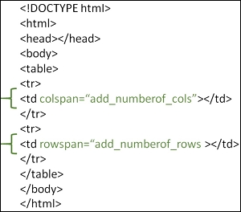

Example

Firstly, we will see how to create a table in HTML with 3 rows and 3 columns

<!DOCTYPE html>

<html>

<head>

<styl

e>

table, th, td {

border: 1px solid black;

width: 100px;

height: 50px;

}

</style>

</head>

<body>

<h1>Heading</h1>

<table>

<tr>

<th></th>

<th></th>

<th></th>

</tr>

<tr>

<td></td>

<td></td>

<td></td>

</tr>

<tr>

<td></td>

<td></td>

</tr>

</table>

</body>

</html>

Output

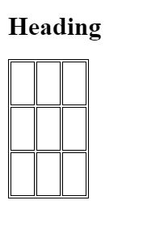

Example

Let’s merge cells using the colspan and rowspan attribute

<!DOCTYPE html>

<html>

<head>

<style>

table, th, td {

border: 1px solid black;

width: 100px;

height: 50px;

}

</style>

</head>

<body>

<h1>Heading</h1>

<table>

<tr>

<th colspan="2"></th>

<th></th>

</tr>

<tr>

<td></td>

<td></td>

<td rowspan="2"></td>

</tr>

<tr>

<td></td>

<td></td>

</tr>

</table>

</body>

</html>

Output

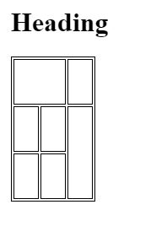

**11)What is the difference between a block-level element and an inline element?**

**Block elements:**They consume the entire width available irrespective of their sufficiency. They always start in a new line and have top and bottom margins. It does not contain any other elements next to it.

* **Examples of Block elements:**
* [**<h1>-<h6>**](https://www.geeksforgeeks.org/html-heading/)**:**This element is used for including headings of different sizes ranging from 1 to 6.
* [**<div>**](https://www.geeksforgeeks.org/div-tag-html/)**:**This is a container tag and is used to make separate divisions of content on the web page.
* [**<hr>**](https://www.geeksforgeeks.org/html-hr-size-attribute/)**:**This is an empty tag and is used for separating content by horizontal lines.
* [**<li>**](https://www.geeksforgeeks.org/html-li-tag/)**:**This tag is used for including list items of an ordered or unordered list.
* [**<ul>**](https://www.geeksforgeeks.org/html-ul-compact-attribute/)**:**This tag is used to make an unordered list.
* [**<ol>**](https://www.geeksforgeeks.org/html-ol-compact-attribute/)**:**This tag is used to make an ordered list.
* [**<p>**](https://www.geeksforgeeks.org/html-basics/)**:**This tag is used to include paragraphs of content in the webpage.
* [**<table>**](https://www.geeksforgeeks.org/html-table-border-attribute/)**:**This tag is used for including the tables in the webpage when there is a need for tabular data.

**HTML 5 Semantic block elements:**

* [**<header>**](https://www.geeksforgeeks.org/html5-semantics/)**:**This tag is used for including all the main things of the webpage like navbar, logos, and heading of the webpage.
* [**<nav>**](https://www.geeksforgeeks.org/html5-semantics/)**:**This tag helps to navigate through different sections by including different blocks of hyperlinks in the webpage.
* [**<footer>**](https://www.geeksforgeeks.org/html5-semantics/)**:**This contains all information about the authorization, contact, and copyright details of the webpage.
* [**<main>**](https://www.geeksforgeeks.org/html5-semantics/)**:**The main content of the webpage resides in this tag.
* [**<section>**](https://www.geeksforgeeks.org/html5-semantics/)**:**This is used separate different sections in the webpage.
* [**<article>**](https://www.geeksforgeeks.org/html5-semantics/)**:**This tag is used to include different independent articles on the webpage.
* [**<aside>**](https://www.geeksforgeeks.org/html5-semantics/)**:**This tag is used to mention details of the main content aside.

**Inline elements:**Inline elements occupy only enough width that is sufficient to it and allows other elements next to it which are inline. Inline elements don’t start from a new line and don’t have top and bottom margins as block elements have.

Examples of**Inline elements**:

* [**<a>**](https://www.geeksforgeeks.org/html-links/)**:**This tag is used for including hyperlinks in the webpage.
* [**<br>**](https://www.geeksforgeeks.org/html-brgt-tag/)**:**This tag is used for mentioning line breaks in the webpage wherever needed.
* [**<script>**](https://www.geeksforgeeks.org/html-script-tag/)**:**This tag is used for including external and internal JavaScript codes.
* [**<input>**](https://www.geeksforgeeks.org/html-input-tag/)**:**This tag is used for taking input from the users and is mainly used in forms.
* [**<img>**](https://www.geeksforgeeks.org/html-img-tag/)**:**This tag is used for including different images in the webpage to add beauty to the webpage.
* [**<span>**](https://www.geeksforgeeks.org/span-tag-html/)**:** This is an inline container that takes necessary space only.
* [**<b>**](https://www.html.am/html-codes/text/html-bold.cfm)**:** This tag is used in places where bold text is needed.
* [**<label>**](https://www.geeksforgeeks.org/html-label-tag/)**:**The tag in HTML is used to provide a usability improvement for mouse users i.e, if a user clicks on the text within the <label> element, it toggles the

**12) How to create a Hyperlink in HTML?**

With HTML, easily add hyperlinks to any HTML page. Link team page, about page, or even a test by creating it a hyperlink. You can also create a hyperlink for an external website. To make a hyperlink in an HTML page, use the <a> and </a> tags, which are the tags used to define the links.

The <a> tag indicates where the hyperlink starts and the </a> tag indicates where it ends. Whatever text gets added inside these tags, will work as a hyperlink. Add the URL for the link in the <a href=” ”>. Just keep in mind that you should use the <a>…</a> tags inside <body>…</body> tags.

**example**

<!DOCTYPE html>

<html>

<body>

<h1>HTML Links</h1>

<p><a href="https://www.myntra.com/">Visit W3Schools.com!</a></p>

</body>

</html>

**output**

# HTML Links

[Visit myntra.com!](https://www.w3schools.com/)

**13) What is the use of an iframe tag?**

**HTML iframe tag Example**

The iframe HTML tag is used to specify the URL of the document to be embedded.

Iframes are often used to embed videos, maps, and other media on a web page. You can also use them to embed another web page into a web page. Here are a few examples of code using iframe to embed an external resource:

<iframe src="http://www.example.com/">

<iframe src="http://www.example.com/" width="400" height="300">

<iframe src="http://www.example.com/" style="border: 0;">

**14) What is the use of a span tag? Explain with example?**

The HTML <span> tag is used for grouping and applying styles to inline elements.

There is a difference between the span tag and the div tag. The span tag is used with inline elements whilst the div tag is used with block-level content.

Example

<!DOCTYPE html>

<html>

<body>

<h1>The span element</h1>

<p>My mother has <span style="color:blue;font-weight:bold">blue</span> eyes and my father has <span style="color:darkolivegreen;font-weight:bold">dark green</span> eyes.</p>

</body>

</html>

**output**

# The span element

My mother has **blue** eyes and my father has **dark green** eyes.

**15) How to insert a picture into a background image of a web page?**

The most common & simple way to add background image is **using the background image attribute inside the <body> tag**. The background attribute which we specified in the <body> tag is not supported in HTML5. Using CSS properties, we can also add background image in a webpage.

<!DOCTYPE html>

<html>

<head>

<style>

p {

background-image: url('img_girl.jpg');

}

**16) How are active links different from normal links?**

The default color for normal and active links is blue. Some browsers recognize an active link when the mouse cursor is placed over that link;

Others recognize active links when the link has the focus. Those that don’t have a mouse cursor over that link is considered a normal link.

### Example

Here, an unvisited link will be green with no underline. A visited link will be pink with no underline. An active link will be yellow and underlined. In addition, when mousing over a link (a:hover) it will become red and underlined:

<style>  
a:link {  
  color: green;  
  background-color: transparent;  
  text-decoration: none;  
}  
  
a:visited {  
  color: pink;  
  background-color: transparent;  
  text-decoration: none;  
}  
  
a:hover {  
  color: red;  
  background-color: transparent;  
  text-decoration: underline;  
}  
  
a:active {  
  color: yellow;  
  background-color: transparent;  
  text-decoration: underline;  
}  
</style>

**17) What are the different tags to separate sections of text?**

**There are three tags that can be used to separate the texts:**

* <br> tag – Usually <br> tag is used to separate the line of text. It breaks the current line and conveys the flow to the next line.
* <p> tag – This contains the text in the form of a new paragraph.
* <blockquote> tag – It is used to define a large quoted section.

**18) What is SVG?**

In this article, we will know **HTML SVG Basics**, & their implementation through the examples. SVG stands for Scalable Vector Graphics. It basically defines vector-based graphics in XML format. SVG graphics do NOT lose any quality if they are zoomed or resized. Every element and every attribute in SVG files can be animated.

**Advantages of SVG:**Advantages of using SVG over other image formats (like JPEG and GIF) are:

* SVG images can be created and edited with any text editor.
* SVG images can be searched, indexed, scripted, and compressed.
* SVG images are scalable.
* SVG images can be printed with high quality at any resolution.

**Example 1:**In this example, We create an SVG line in HTML.

<!DOCTYPE html>

<html>

<body>

  <h2>hi my name is divya</h2>

  <svg height="250" width="600">

    <line x1="10" y1="10" x2="400" y2="400"

          style="stroke:rgb(0,0,255);stroke-width:3" />

  </svg>

</body>

</html>

**Example 2:**Drawing A SVG Circle in HTML

|  |
| --- |
| <!DOCTYPE html>  <html>  <body>    <!-- html svg tag is used here -->    <svg width="200" height="200">      <circle cx="80" cy="80" r="50" stroke="black"              stroke-width="2" fill="grey" />    </svg>  </body>  </html>  output  https://media.geeksforgeeks.org/wp-content/uploads/Screen-Shot-2017-11-16-at-8.38.42-PM.png |

**Example 3:** Drawing A SVG Rectangle in HTML

|  |
| --- |
| <DOCTYPE html>    <html>    <body>      <!-- html svg tag is used here -->      <svg width="400" height="100">        <rect width="400" height="100"              style="fill: rgb(0, 0, 255);                     stroke-width: 10; stroke: rgb(0, 0, 0)" />      </svg>    </body>      </html> |

**Output:**

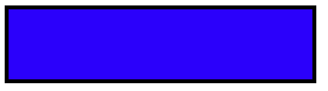

**Example 4:**Drawing A SVG Rounded Rectangle in HTML

|  |
| --- |
| <!DOCTYPE html>  <html>    <body>    <!-- html svg tag is used here -->    <svg width="400" height="380">      <rect x="80" y="20" rx="20"            ry="20" width="150"            height="150"        style="fill: orange;               stroke: black;               stroke-width: 2;               opacity: 0.5" />    </svg>  </body>  </html> |

**Output:**

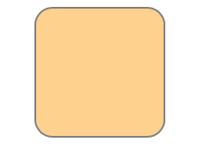

**Example 5:**Drawing A SVG Star in HTML

|  |
| --- |
| <!DOCTYPE html>  <html>  <body>    <!-- html svg tag is used here -->    <svg width="300" height="200">      <polygon points="100,10 40,198 190,78 10,78 160,198"        style="fill: grey; stroke: orange;               stroke-width: 5; fill-rule: evenodd" />    </svg>  </body>  </html> |

**Output:**



**Example 6:**Drawing A Logo in HTML using SVG

|  |
| --- |
| <!DOCTYPE html>  <html>  <body>    <!-- html svg tag is used here -->    <svg height="300" width="700">      <defs>        <linearGradient id="grad1" x1="0%"                        y1="0%" x2="100%"                        y2="0%">          <stop offset="0%"                style="stop-color: white; stop-opacity: 1" />          <stop offset="100%"                style="stop-color: green; stop-opacity: 1" />        </linearGradient>      </defs>      <ellipse cx="200" cy="100"               rx="120" ry="80"               fill="url(#grad1)" />      <text fill="#ffffff" font-size="22"            font-family="ARIAL"            x="120" y="110">        logo      </text>    </svg>  </body>  </html>  output  https://www.tutorialspoint.com/assets/questions/media/3307/logo.jpg  **19)What is difference between HTML and XHTML?**  **HTML:**  HTML is short for Hypertext Markup Language. It is used to create websites and web applications. Let’s break it down, so we understand the name better:   * Hypertext: Hypertext refers to the “text wrapped within a text.” It is very similar to hyperlinks and contains an underlying text that, when clicked, redirects to a new webpage. * Markup language: A markup language is not necessarily a programming language. Instead, it is used to apply formatting and layout to a simple text document. This leads to more interactive and dynamic text content.   **XHTML:**   * XHTML stands for Extensible Hypertext Markup Language * XHTML is almost similar to HTML but it is stricter than HTML * It is swift, accurate, easily maintained, convertible, and formatted * All major browsers support XHTML   **20) What are logical and physical tags in HTML?**  **Logical tags :** Logical tags are used to tell the meaning of the enclosed text. The example of the logical tag is <strong> </strong> tag. When we enclose the text in the strong tag, it tells the browser that enclosed text is more important than other texts.    **Physical tags :** Physical tags are used to tell the browser how to display the text enclosed in the physical tag. Some of the examples of physical tags are <b>, <big>, <i>. |

**THANL YOU**